Practical no:-

Aim:-

Query:-

create table client_master1234

(

clientno varchar2(6) primary key,

cname varchar2(20) not null,

address varchar2(30),

city varchar2(20),

state varchar2(20),

balance number(10,2)

);

Output:-

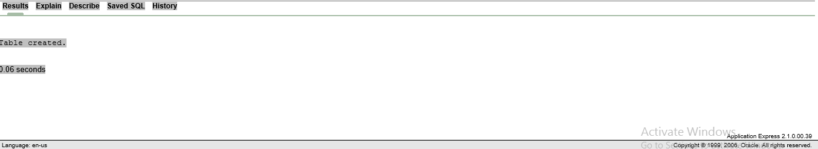

Query:-

insert into client_master1234 values('c0001','rahul mane','siddharath nagar ','boisar','Maharashtra',15000);

insert into client_master1234 values('c0002','mukesh raut','siddharath nagar ','','Maharashtra',15);

select*from client_master1234;

output:-

